International Conference on “Social Movements: The Struggle for Alternative Economies” ||| Palestine 2023
Attendance confirmation form
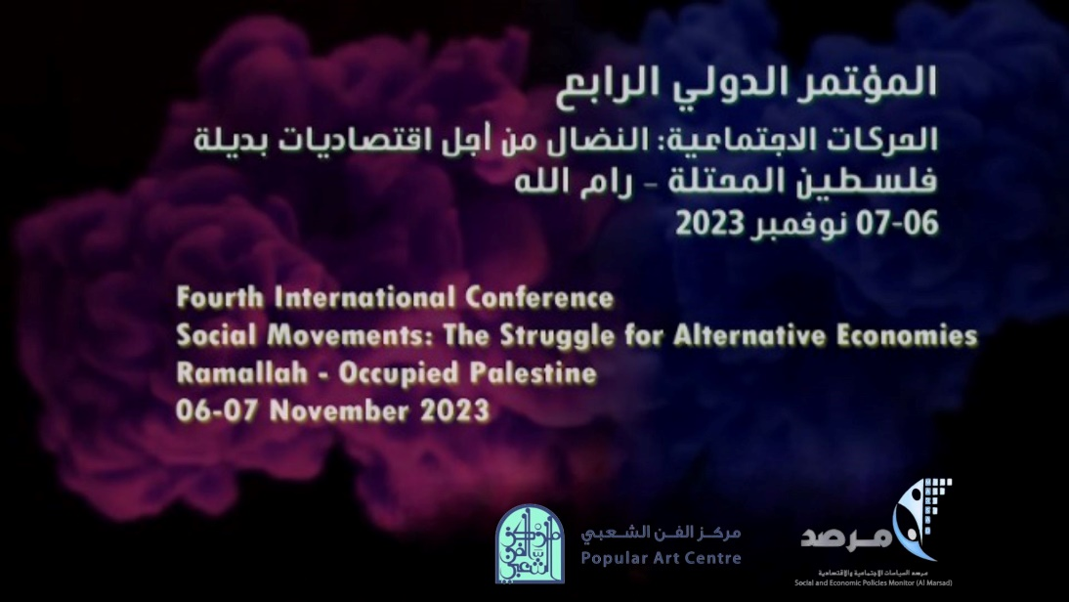
The Organizing Committee of the Conference sends you their kindest regards.
- The conference will be held between 06 – 07 November 2023.
- Conference Venue will be in Ramallah City, West Bank.
- Personal Details and Information:

Middle Name (If applicable) | First Name |  |  | Last Name
Phone Number |  | Email Address
Organization/ Affiliation |  |  | Job Title/ Occupancy

Other Details/ Requirement:
I will be attending during the first day of the conference YES NO
I will be attending during the second day of the conference YES NO

Please send filled out document through email to abed@almarsad.ps
Best regards,

